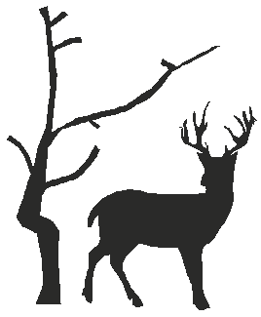
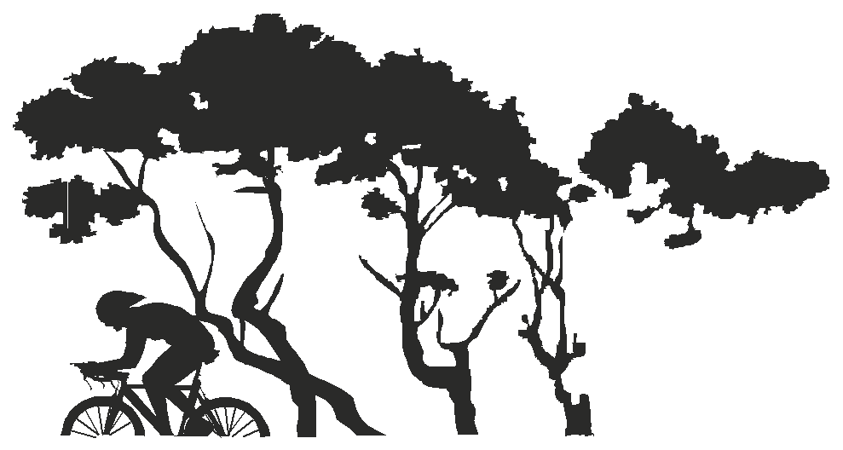

PLEASE CONTACT: EVENT SECRETARY Sally Withey CLUB WEBSITE www.ccbreckland.info
54 Norvic Drive, Norwich, NR4 7NW e-mail sallywithey@cyclingtimetrials.org.uk

10 miles Time Trial – Results
Promoted for and on behalf of Cycling Time Trials under its rules and regulations
on Saturday, 5 March 2022 - Course B10/19

TIMEKEEPERS

START: Andy Moore – C C Breckland

FINISH: Heather Saunders, Emily Osborne – C C Breckland

OBSERVER: Don Saunders – C C Breckland

MARSHALLS: Carbrooke roundabout – Dan Blackburn, Epic Orange, Paul Vergette, Godric CC, Bruce Williams, North Norfolk Wheelers.

Pedestrian crossing – Michael Wood, C C Breckland

Carbrooke/Broadmoor Crossroads – Phil Hollingsworth EACC, Roger Sayer, C C Breckland.

Well done to all the riders at this event, the weather was far from pleasant being cold and wet. A big thank you to the timekeepers and marshals who stood out in the rain and made the event possible.

.
Prizes – one rider: one prize.

Mens
1st Lloyd Chapman – Loose Cannon’s Conditioning 21:14 £25
2nd Jordan Black – West Suffolk Wheelers 21:16 £20
3rd Simon Butteriss, Ely & District CC/B&T Motor Repairs 22:19 £15
3rd Ryan Gray, Ride Harder 22:19 £15

Women
1st Hannah O’Brien – Loose Cannon’s Conditioning 23:56 £25
2nd Verity Smith – Loose Cannon’s Conditioning 24:28 £20
3rd Isabella Johnson, Datalynx-Parenesis Cycling 26:52 £15

VETS on Std: Prizes
1st Keith Dorling, Team Bottrill +6:03 £25 (under one prize per rider)
2nd Mike Watson, Lowestoft Wheelers Cycling Club +4:11 - £20 (under one prize per rider)
3rd Ian Short, Team Salesengine.co.uk +3:55 - £15 (under one prize per rider)

TEAM: Loose Cannon’s Conditioning - £10 Each – Lloyd Chapman, Hannah O’Brien and Verity Smith

